2022 Calendar

 | Picture description  Align under picture far right | Monthly slogan  Align under monthly calendar centre page  Please insert the following vision statement on the cover page under the top of title
Cover page | Hall Creek Tether System, Kootenay Lake Field Team | “Dependable, Sustainable, Connected”  The Land….The People….The Business
Jan 4 | Cranberry Ridge, Boundary Field Team | Winter Safety. File your field itinerary and assess the daily risks
Feb 5 | The People, Kootenay Business Area | Committed to Safety
March 2 | Big Sheep Creek, Arrow Field Team | You achieve safety excellence when well prepared for the risk
April 3 | Freeman Creek, Kootenay Lake Field Team | Put the brakes on bridge speed crossings.
May 2 | Larch seedling, East Kootenay Field Team | Safety is an investment in your future
June 3 | Large Cedar, Kootenay Business Area | Tomorrow – Your reward for working safely today
July 3 | State – Deer Creek, Boundary Field Team | Know your safety evacuation plan and keep your emergency routes clear and clean.
August 2 | Sunset over Kootenay Lake | Safety requires a TEAM effort
Sept 3 | Garrity, Kootenay Lake Field Team | BCTS Working together to ensure a safe and healthy work environment
Oct 4 | Prescribed burn, Boundary Field Team | Plan your escape routes, safety zones and ensure your communication lines are open
Nov 3 | Gloucester – Boundary Field Team | Safety is Good Business
Dec 2 | Elmer Creek, Kootenay Lake Field Team | BCTS is on Mission Zero  “Assess, Report, Control”
Back Cover

See below more information

Also would like to add one of our safety stickers slogans to every month under the same line as SFI and Safe Certification label, these can be rotated every 3 months (so each logo would be on the calendar 4 times).

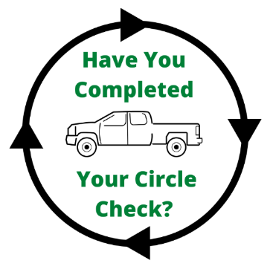 | 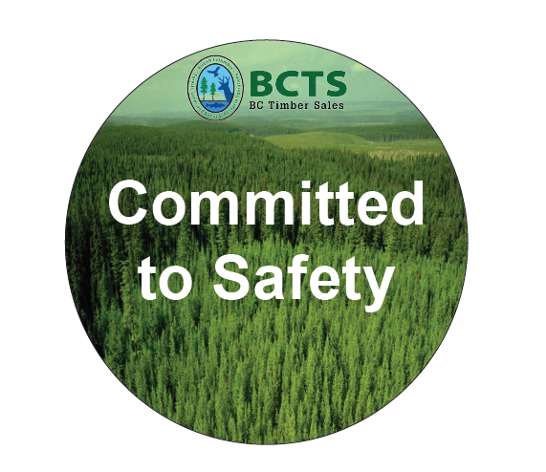 | 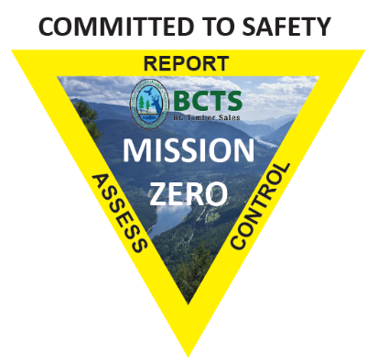

In addition to the regular stat holidays and significant days, please add the following special dates and statements to dates identified for 2022 Calendar:

January 5th, 2022 3rd Quarter Report
February 2, 2022 Ground Hog Day

March 8, 2022 International Women’s Day
March 13, 2022 Daylight Savings time
March 20, 2022 Spring Equinox
March 21, 2022 International Day of Forests
March 31, 2022 Fiscal Year End

April 6, 2022 4th Quarter Report
April 22, 2022 Earth Day
April 27, 2022 Administrative Professionals Day

June 21, 2022 Summer Solstice
June 21, 2022 National Indigenous Peoples Day
June 30, 2022 1st Quarter Reports

July 4, 2022 Independence Day (USA)
August 19, 2022 5 YR Business Plan Due
Sept 18, 2022 National Forest Week
Sept 22, 2022 Fall Equinox
Sept 29, 2022 2nd Quarter Reports

Nov 6, 2022 Daylight Savings Time
Nov 24, 2022 Thanksgiving Day (USA)
December 7 20221 Prep for 3rd Quarter Financial Reports
December 14, 2022 Rollup of new 5-Year Budget
December 21, 2022 Winter Solstice

